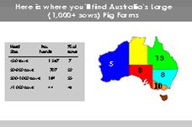
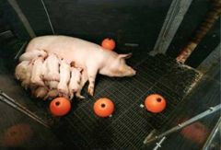
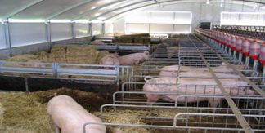

The Science & Practice of Pig Production
Course 2017

30 January 2016 – 10 February 2017

Registration form

Name & Title
Organisation
Mobile
Email
Postal Address
Accommodation | Date In: | Date Out:
Bus to/from Airport | From: Yes/No | To: Yes/No
Any special requirements
Would you be interested in a winery tour on Saturday 4th February? (It would be at your cost approx. $80pp) | Yes/No

Please complete and return to Rebecca.smith@porkcrc.com.au
And C.C.
william.vanwettere@adelaide.edu.au

