Information for researchers wanting to lodge proposals for Pork CRC (2017-2018) investment round
Pork CRC moves to PigNet
As part of our transition from Pork CRC to APRIL (Australasian Pork Research Institute Limited) we moved our project management from FutureAct to a common platform with APL, PigNet, from the 2016/17 investment round.
PigNet will be used again for the 2017/18 investment round for receiving and evaluating proposals.
The 2017/18 Investment Round opens on November 24, 2016 and closes on January 9, 2017.
The Process
Most researchers are familiar with the system and will be able to log in using their current user name and password.
Others will need to register at https://www.pignet.com.au/ . Once you have registered an email will be sent to you to confirm your registration.
Application Steps
- Log In to PigNet
- Download Budget Spreadsheet – “Document downloads”. The downloaded spreadsheet will appear in the bottom left hand corner of the page. Please see diagrams below for further instructions.
- Go to “My Applications”
- Under “Create an application” click on “New” or go to step 5
- Click on “Pork CRC” as the funding body
- Complete each section of the application form
The process is fairly straight forward and all sections need to be completed before an application can be submitted.
Essential Attachment
For all Pork CRC applications, you will need to attach our budget and milestone spread sheet (appropriately and correctly filled in) before submitting your application (see below for instructions on downloading the spreadsheet).
Up to 2 other documents can also be attached as part of the application using the “Attachment” feature included in the online application.
Otherwise the system is fairly straightforward but if you have any problems give us a call and we will see if we can assist.
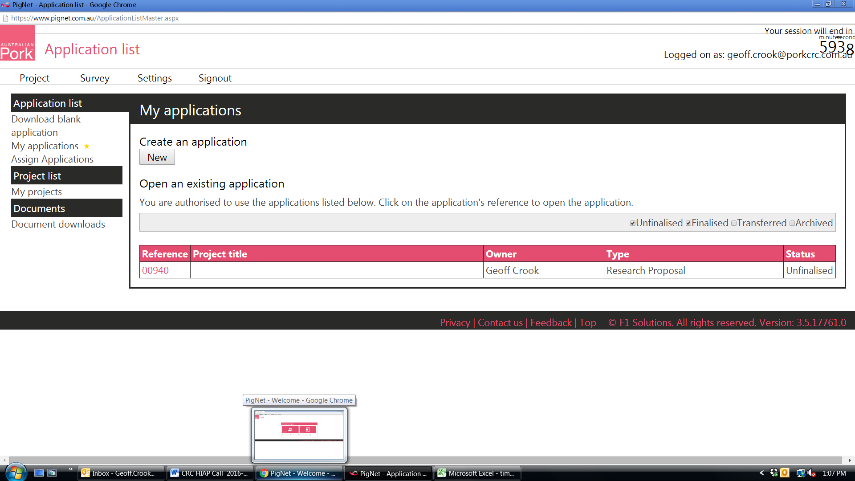
After logging in to PigNet, Pork CRC Budget and Milestones spreadsheet can be found by clicking here

