Information for researchers wanting to lodge proposals for Australasian Pork Research Institute Ltd (APRIL)
2018/19 investment round
Applications through Pork CRC Omnistar system
As part of our transition from Pork CRC to APRIL (Australasian Pork Research Institute Limited) the first APRIL investment round will utilise Pork CRC’s Omnistar system:
https://porkcrcomnistar.f1solutions.com.au/
Note: APRIL is using Pork CRC’s system and not APL’s PigNet
The 2018/19 Investment Round opens on December 11, 2017 and closes at 10:00pm on February 16, 2018.
The Process
Most researchers are familiar with the system as it is based on APL’s PigNet system and will be able to log in using their current user name and password – a password reset may be required if this is the first time you have used the Pork CRC Omnistar system.
Others will need to register at https://porkcrcomnistar.f1solutions.com.au/. Once you have registered, an email will be sent to you to confirm your registration.
Application Steps
- Log In to Omnistar
- Download Budget Spreadsheet –Please see diagrams below for further instructions.
- Click on:
- Complete each section of the application form
- Upload completed Budget and Milestone spreadsheet at the “Attachments” question
- Finalise application
- You can down load your application and attachments once you have clicked on finalise application (see diagrams below)
- You will receive an email notifying you that your application has been successfully lodged.
The process is straightforward and all sections need to be completed before an application can be submitted.
Essential Attachment
For all APRIL applications, you will need to attach our budget and milestone spread sheet (appropriately and correctly filled in) using the “Attachment” feature included in the online application before submitting your application (see below for instructions on downloading the spreadsheet).
Contact details
If you have any problems, give us a call and we will see if we can assist.
For Omnistar related questions:
Mr Geoff Crook on 08 8313 7684 or at Geoff.crook@porkcrc.com.au
For Research Project related questions:
Dr Roger Campbell on 0407 774 714 or at roger.campbell@porkcrc.com.au
For Commercialisation Project related questions:
Dr Charles Rikard-Bell on 0439 513 723 or at Charles.rikard-bell@porkcrc.com.au

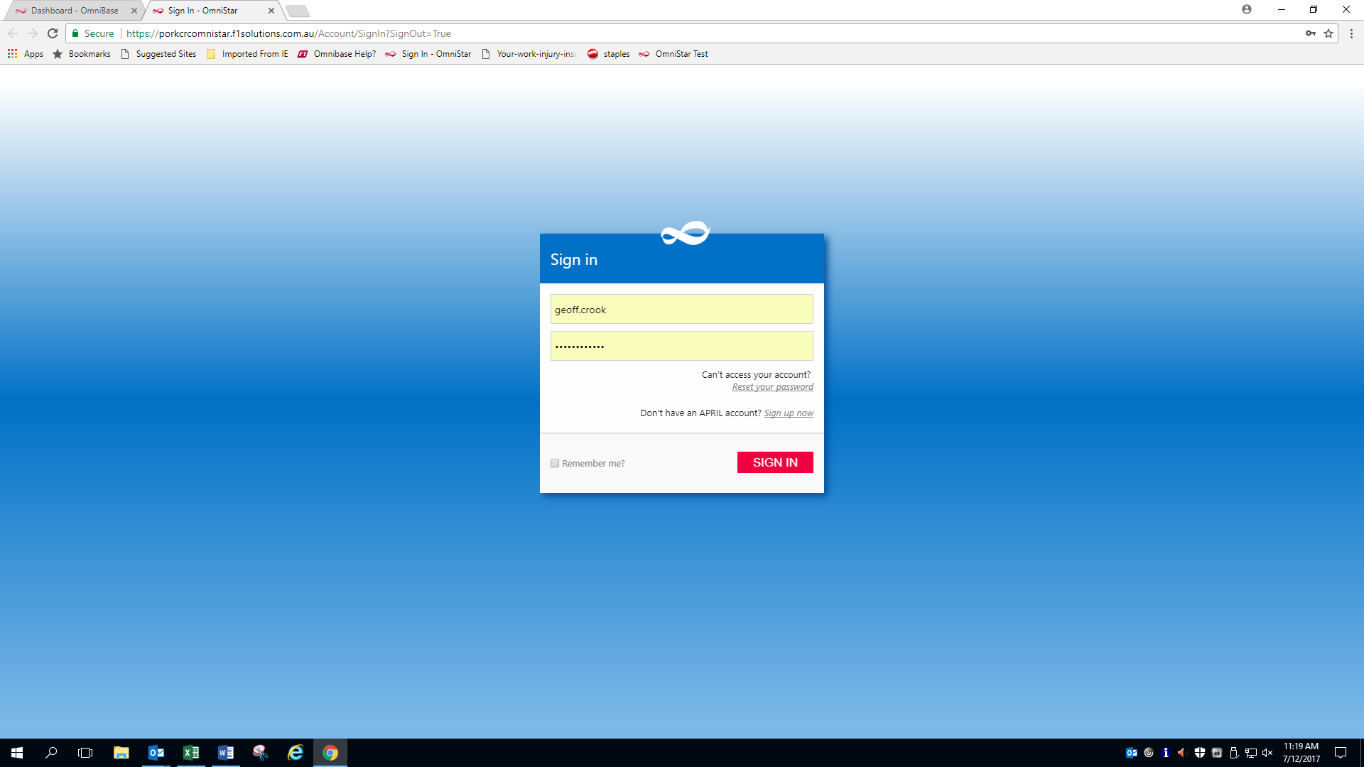
Register by clicking here
Reset your password by clicking here

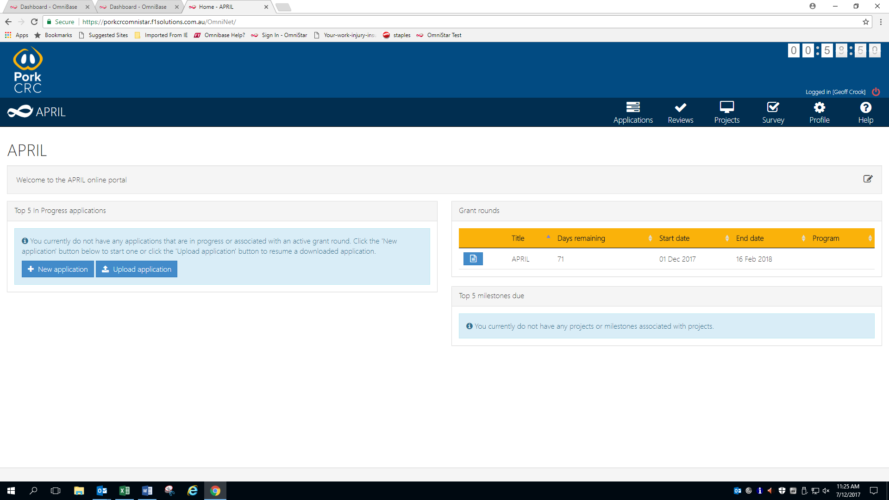
Download Application documents including budget spreadsheet by clicking here

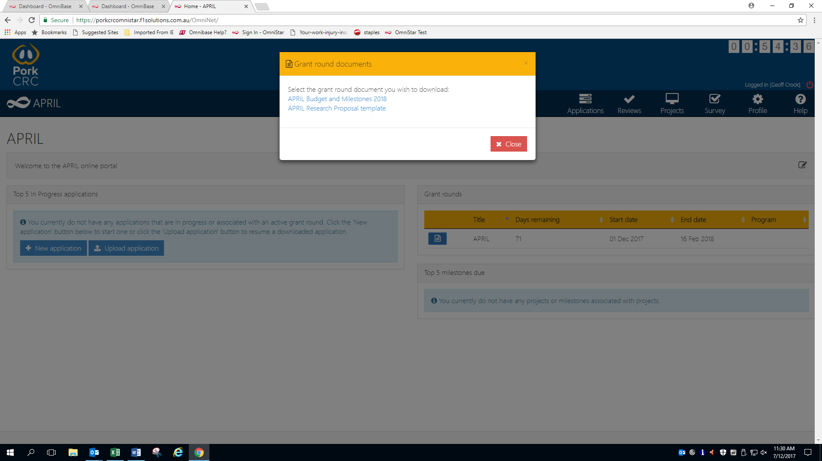
Download budget spreadsheet by clicking here

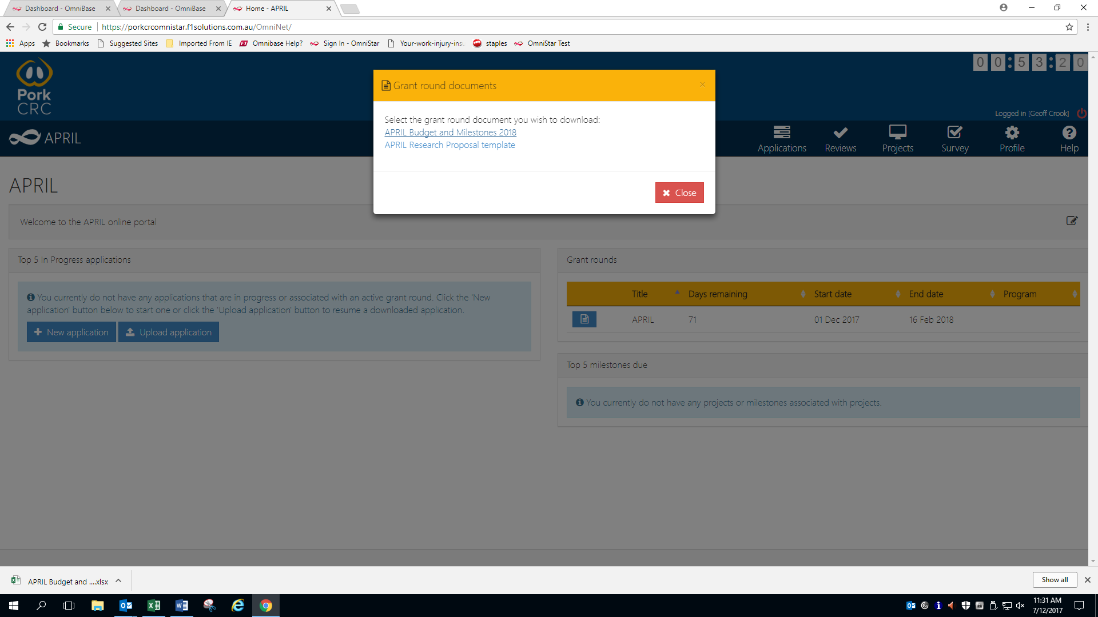
You can now start your application by clicking here
budget spreadsheet will appear here

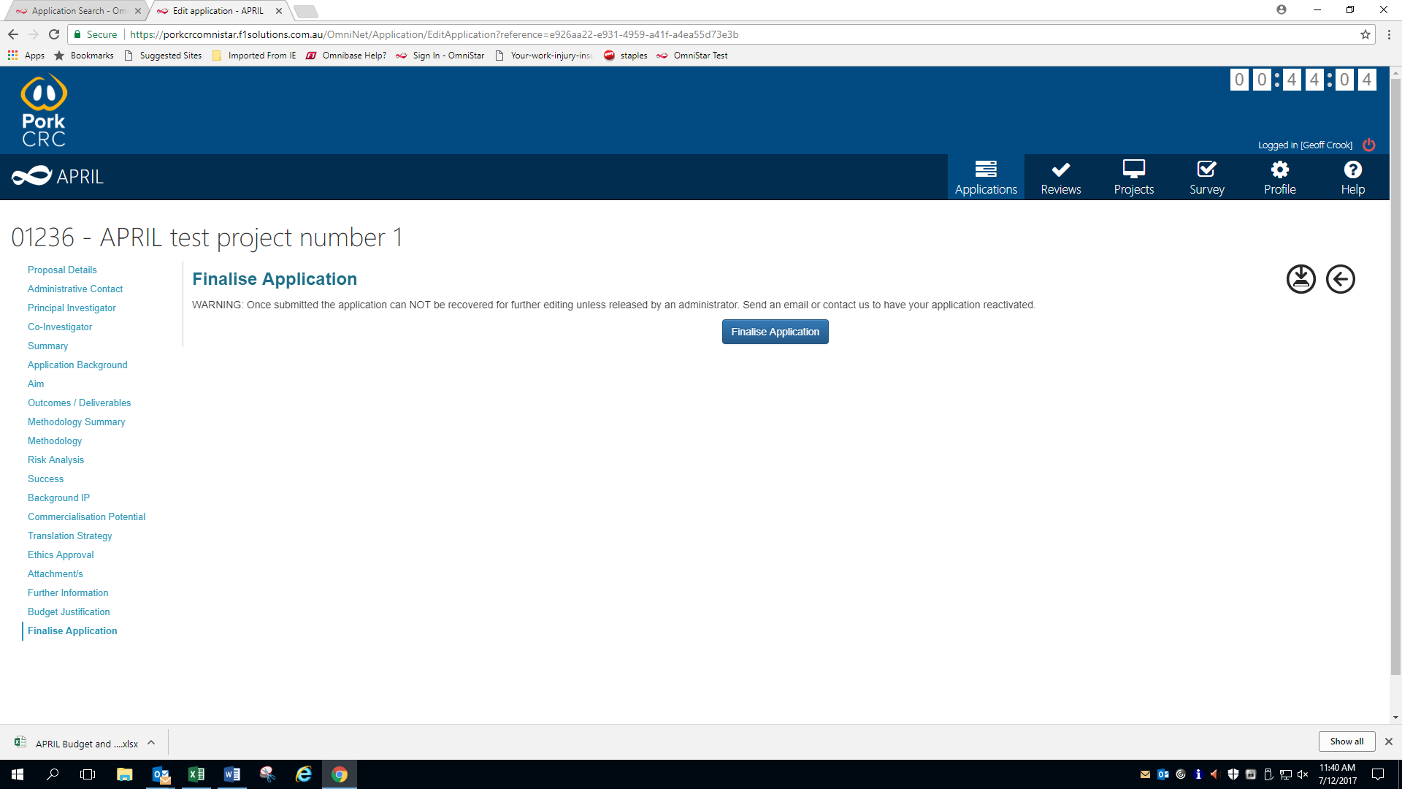
Submit your application here – (you can download a copy of the application on the next screen)
Save a copy of your application that can be uploaded later here – (*.omni file)

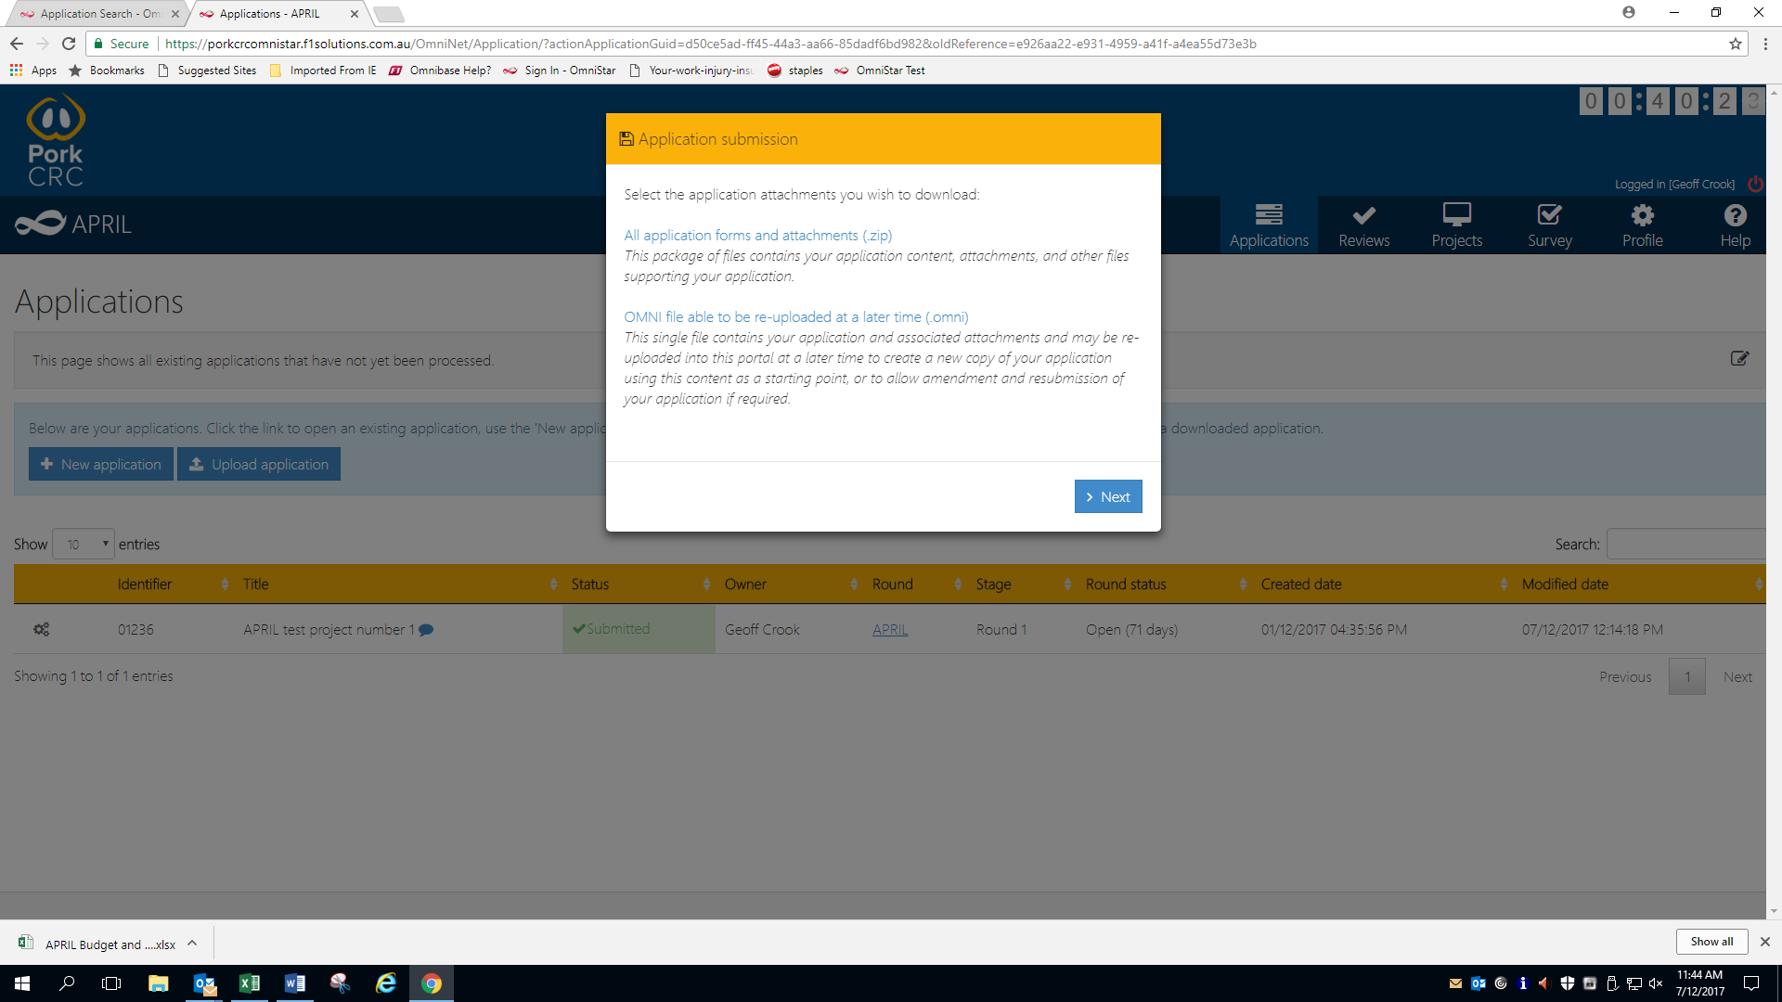
Save a word copy of your application and the budget spreadsheet here

Save a copy of your application that can be uploaded later here – (*.omni file)

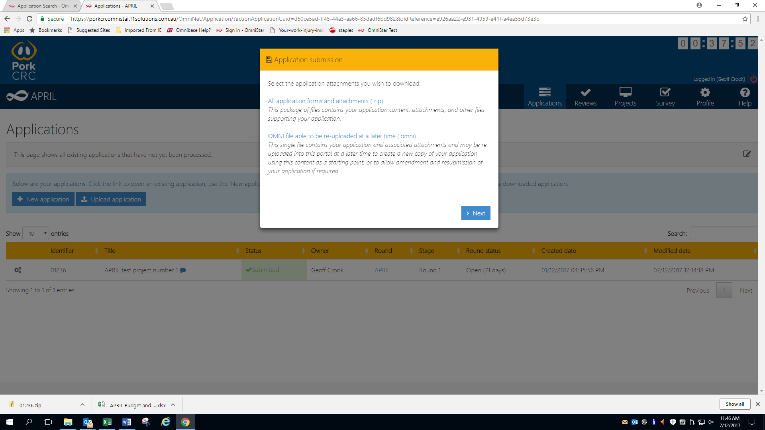
Complete submission by clicking here
Zip file containing word version of application and budget spreadsheet will appear here

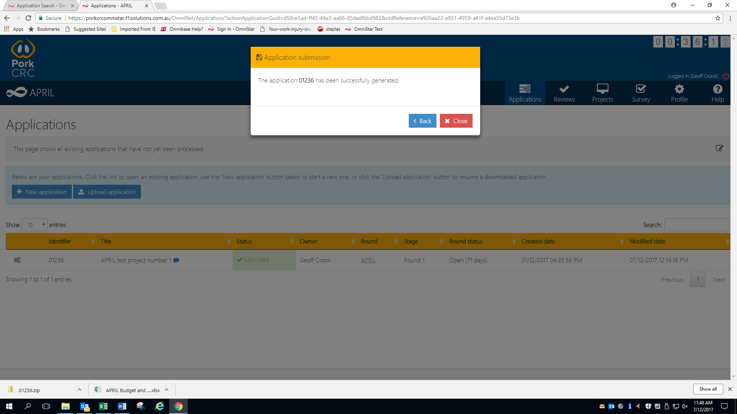

Once your application has been submitted successfully, you will receive an email as follows:
This will have a copy of the Word version of the application and budget spreadsheet attached

